**M.Sc C.S - I**

**SEM I**

**E-Journal**

|  |  |
| --- | --- |
| **Roll No.** | 027 |
| **Name** | OJHA ABHISHEK DEVMANI |
| **Subject** | ADVANCED COMPUTER NETWORK |

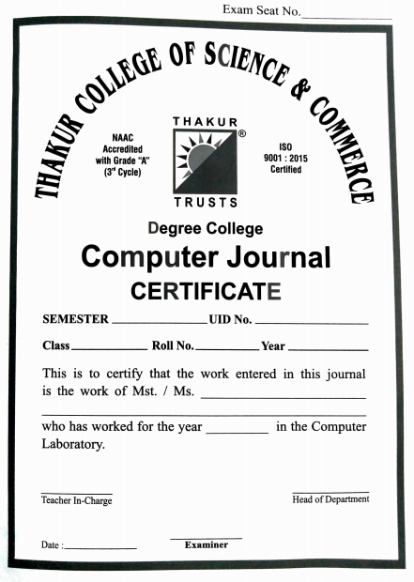

**027**

**24-12-2021**

**Ashish Trivedi**

**Neha Kamble**

**2021-2022**

**Ojha Abhishek Devmani**

**2021-2022**

**MSc-CS**

**Sem - I**



CERTIFICATE

This is here to certify that Mr. **OJHA ABHISHEK DEVMANI**, Seat Number **027** of M.Sc. I Computer Science, has satisfactorily completed the required number of experiments prescribed by the UNIVERSITY OF MUMBAI during the academic year 2021 – 2022.

Date: **24/12/2021**

Place: **Mumbai**

Teacher In-Charge Head of Department

**Neha Kamble** **Ashish Trivedi**

External Examiner

**INDEX**

|  |  |  |
| --- | --- | --- |
| **Sr. No.** | **Practical Name** | **Date** |
| **1** | Create a network with three routers with RIPv2 algorithm and each router associated network will have minimum three PC. Show connectivity. | 24-09-2021 |
| **2** | Create a network with three routers with OSPF algorithm and each router associated network will have minimum three PC. Show connectivity. | 01-10-2021 |
| **3** | Create a network with three routers with BGP algorithm and each router associated network will have minimum three PC. Show connectivity. | 08-10-2021 |
| **4** | Configure DHCP server and client for DHCP service. | 15-10-2021 |
| **5** | Create virtual PC based network using virtualization software and virtual NIC. Show connectivity to Internet as well as connectivity to VMs in other network. | 22-10-2021 |
| **6** | Create network cloud and hosts. | 29-10-2021 |
| **7** | Create simple Adhoc network | 05-11-2021 |
| **8** | Create MANET simulation for AODVUU Network | 12-11-2021 |
| **9** | Create Single mobile network | 19-11-2021 |